Video 4 Android Emulator

Mobile device emulator for Andorid PWA video 4

<https://www.youtube.com/watch?v=1VVKhnHNBeQ>

android Studio

Device preview options

developer android com

<https://developer.android.com/studio>

Go to config and set up

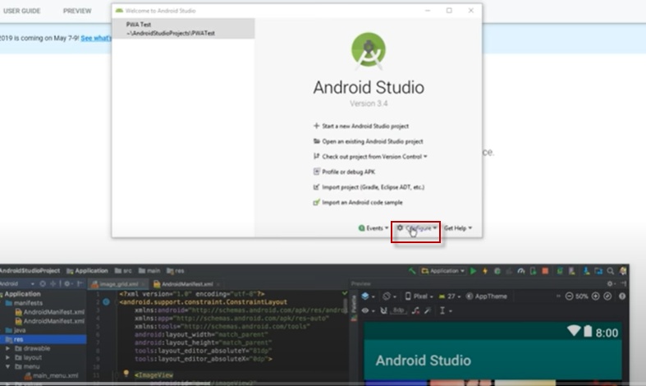

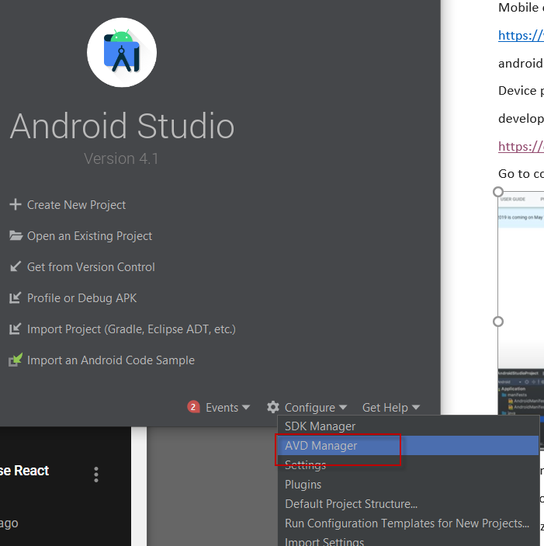

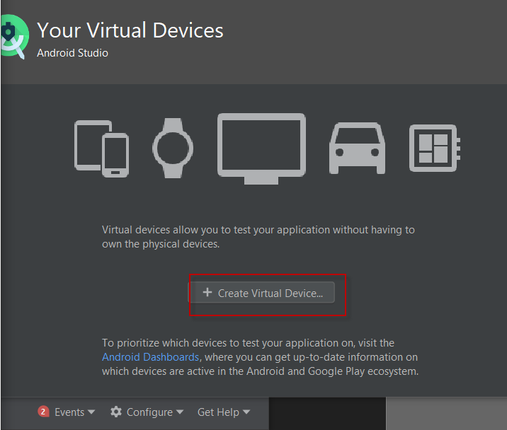

Errors in events

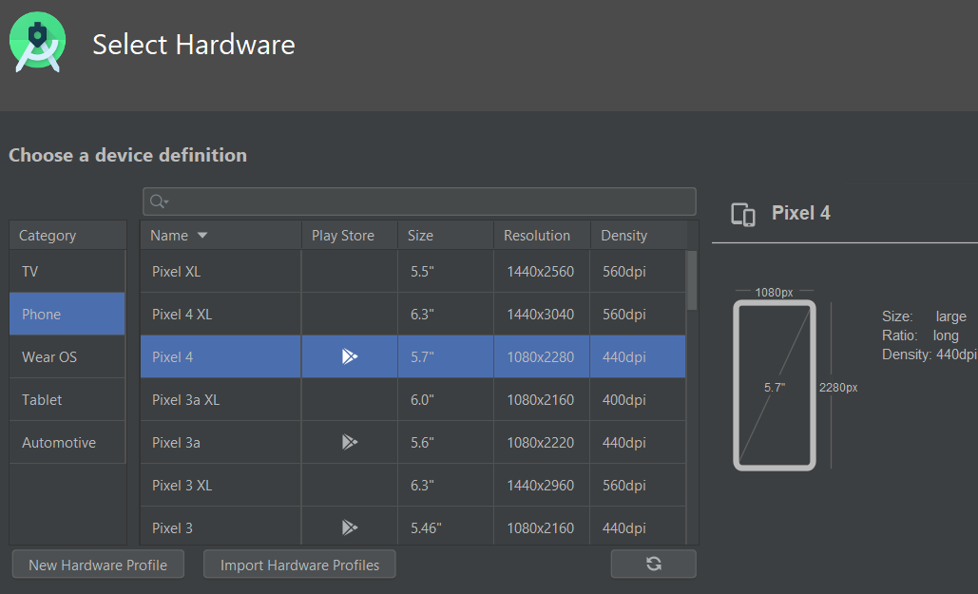

Install Pie and HAXM installer emulator accelerator

Name the device and use portrait mode

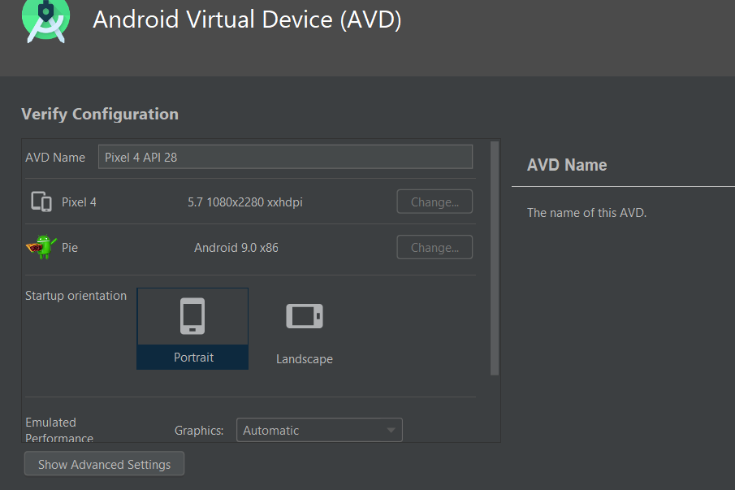

Emulator accelerator – Is it installed?  This may cause an error

I had a couple of errors – one was something about DART the other was software update available.

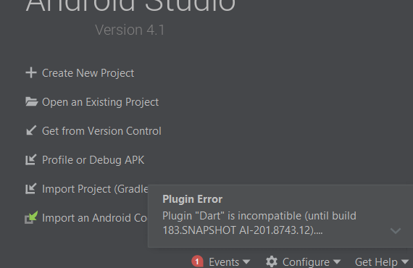

Plugin "Dart" is incompatible (until build 183.SNAPSHOT AI-201.8743.12). Plugin "Flutter" is incompatible (until build 183.SNAPSHOT AI-201.8743.12).

Tried again and got this – but it was actually running

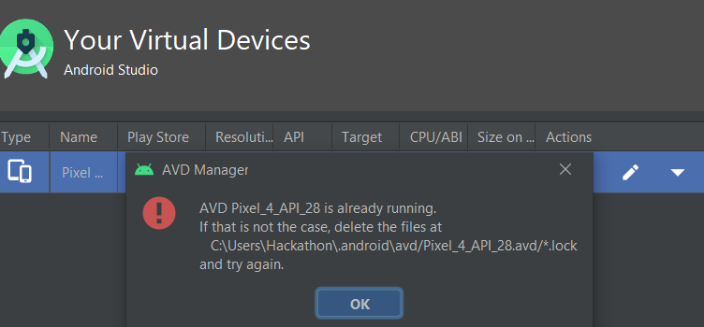

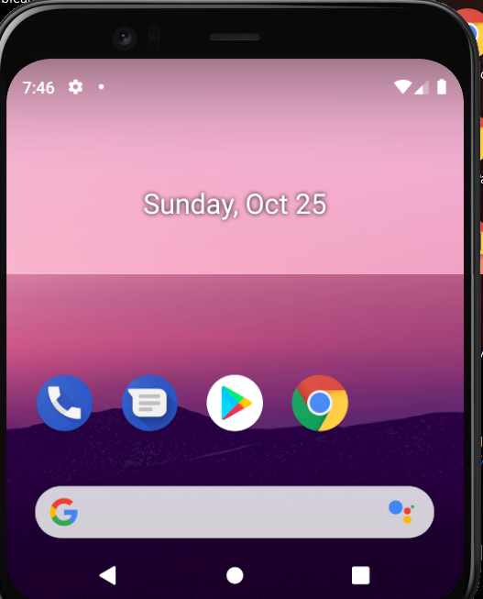

Virtualization technology – is it on ?  Edit bios F10 on start up 3:42 into video

Open the browser on the device and  go to the URL (on the network) on which app is running. Local host served up on local computer.  But the android emulator is set up as segregated from the machine so have to go to a proxy address [10.0.2.2:5000](http://10.0.2.2:5000/)

  or whatever the port is that you are using

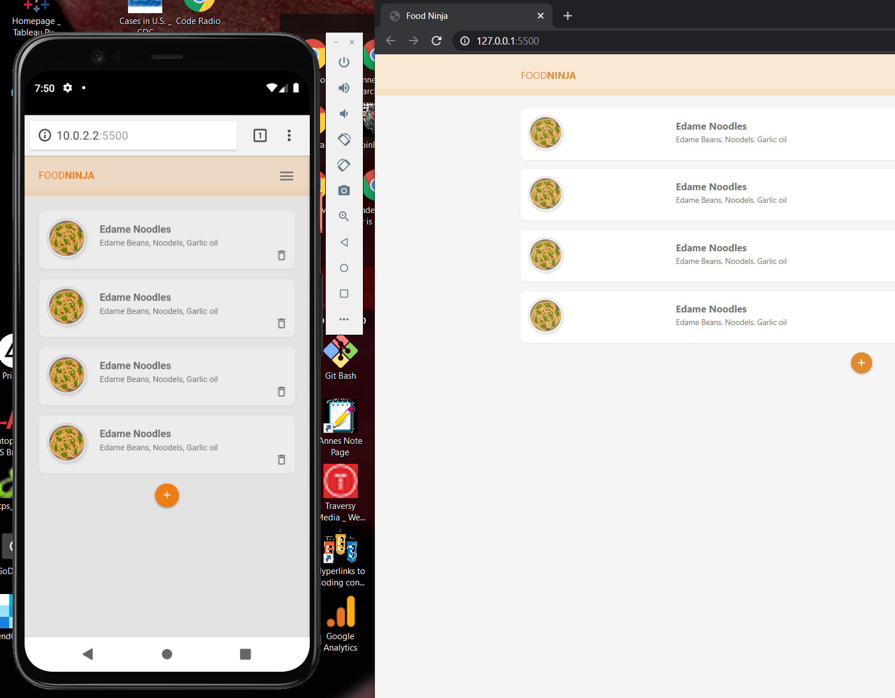

Add to home screen under more menu

Once you open from home screen it will not show browser- will look like a native app

Will cover how to add to homescreen without having to manually do it.